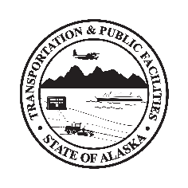
Department of Transportation & Public Facilities
Insert Building or Section Name here before printing

Elevator Use

By recommendation of State Health Alerts, Workplace Policy, and DOT&PF COVID-19 Operating Plan, employees are advised to promote public health and fight COVID-19 by following public health guidance.

Maximum Occupancy: Insert # here

All users are required to

- Wear a cloth face covering if unable to keep 6 feet from others
- Cover coughs and sneeze into sleeve or elbow--not hand
- Upon exiting, remember to wash or sanitize hands if you have touched elevator controls/surfaces

State Health Alerts at coronavirus.alaska.gov
DOT&PF COVID-19 Operating Plan at web.dot.state.ak.us/comm/documents/COVID-Business-Plan.pdf

