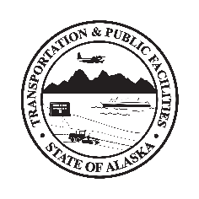
Department of Transportation & Public Facilities
Insert Building or Section Name here before printing

Conference Room Use

By recommendation of State Health Alerts, Workplace Policy, and DOT&PF COVID-19 Operating Plan, employees are advised to promote public health and fight COVID-19 by following public health guidance.

Maximum Occupancy: Insert # here

All users are required to

- Observe maximum occupancy
- Prior to use, clean & disinfect commonly-touched surfaces such as doorknobs, light switches, tabletops & chair handles/arms
- Increase ventilation by opening windows/doors if possible
- Non-employee attendees must sign-in/out at front desk
- Provide hand sanitizer at door to clean hands
- Wear a cloth face covering if unable to keep 6 feet from others while in this room, halls, other common areas and offices
- Use noncontact methods of greeting
- Cover coughs and sneeze into sleeve or elbow--not hand
- Limit food-sharing and clean up kitchen
- After use, re-clean & -disinfect all commonly-touched surfaces for the next user
- Close & re-lock windows/doors

State Health Alerts at coronavirus.alaska.gov
DOT&PF COVID-19 Operating Plan at web.dot.state.ak.us/comm/covid-office-operating-plan.shtml

